CORNER STONE BAPTIST CHURCH SUPPORTED MISSIONS

ARRINDELL, EDDIE & RITA
Virgin Islands, St. Thomas

AU, ANDREW & ELENA
Hong Kong, China
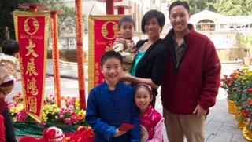

BEARD, ED & MARY
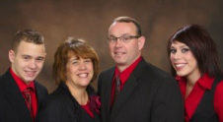
Annapolis, MD

BOHMAN, ERICA
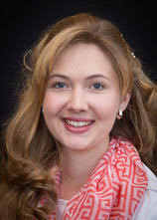
Kenya Africa

BURWELL, CLIFF CHARLOTTE
Evangelist, U.S.A
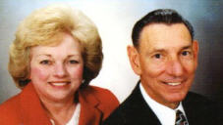

CASTILLO, WELLINGTON & YENNY
Santo Domingo, Dominican Republic
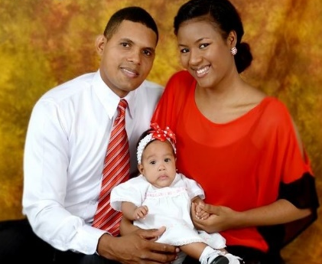

CAUDLE, JOHN & DEBORAH
Ontaria, Canada
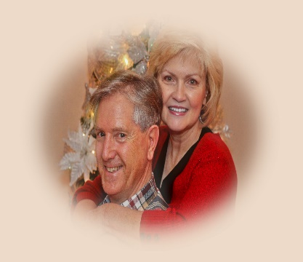

CREED, PAT & JUNE
Caribbean International Rep.
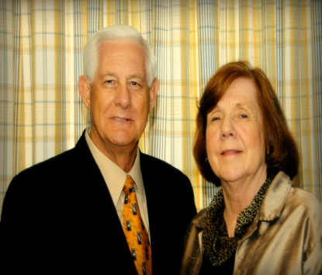

DOVE, JR., RICK & SHANNON
Atenas, Costa Rico
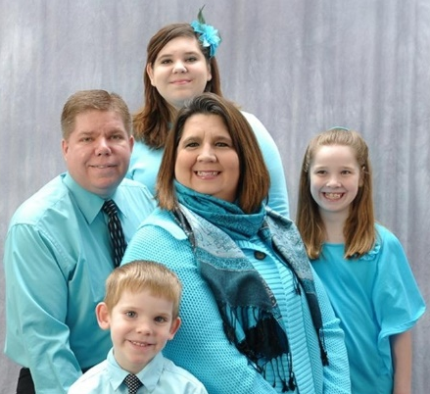

EASTEP, SAMUEL & BRENDA
Mexico City, Mexico

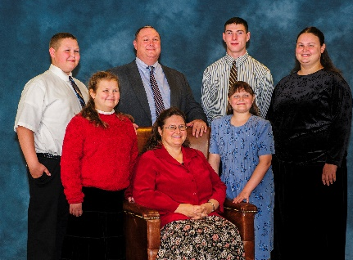

FASINRO, YINKA & VANESSA
Nigeria, West Africa
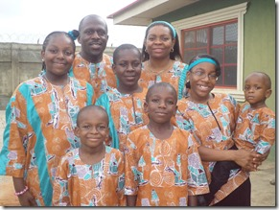

GARRIS, ANTHONY & BRENDA
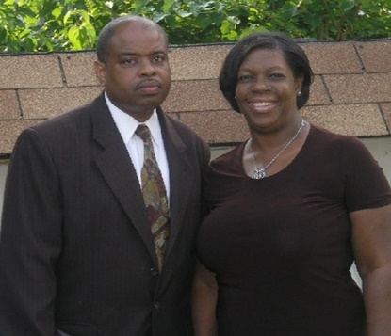
Inner City Baptist Church, NJ

GIVANS, ALEXIS & CONSUELO
Dominican Republic

HALL, JON & MARIE
Taree, New South Wales Australia

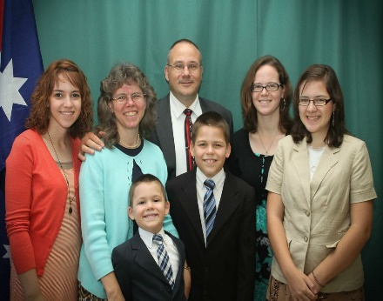

HAYES, JUSTIN & GRACE
Dos Hermanas, Spain
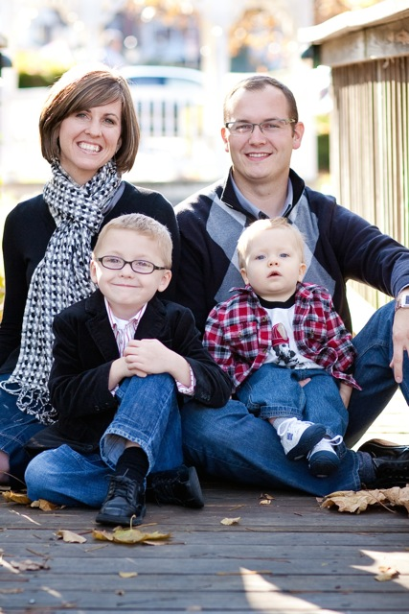

HERBERLE, JIM & BECKY
Outback Queensland, Australia
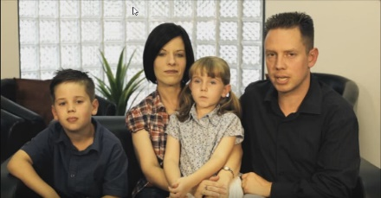

HORNBECK, JOHN & LEEETTA
U.S. Military, Aviano, Italy
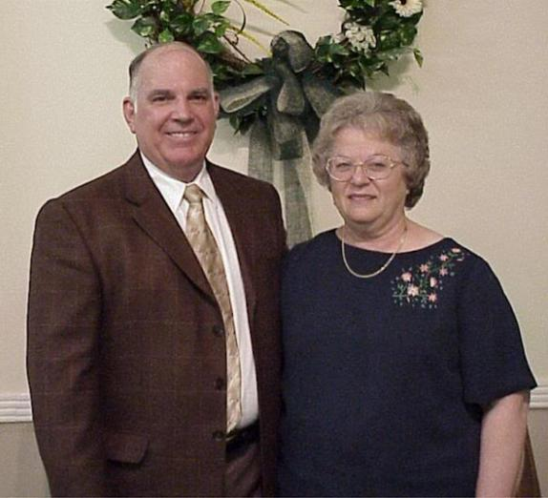

INDEP CHURCH PLANTING
DelMarVa

JEHOVAH JIREH MINISTRIES
James & Lois Bosse
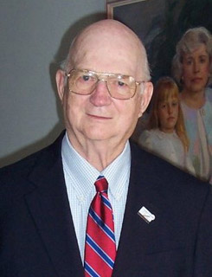

JOHNSON, ERIK & HOLLY
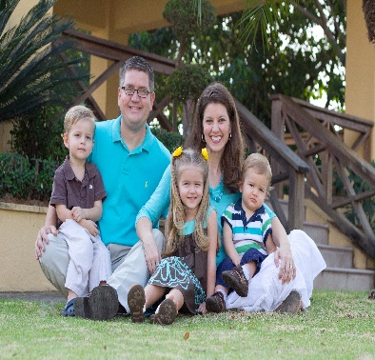
Constanza Dominican Republic

KEARNEY, FREDRICK & ANTOINETTE
Ghana West Africa
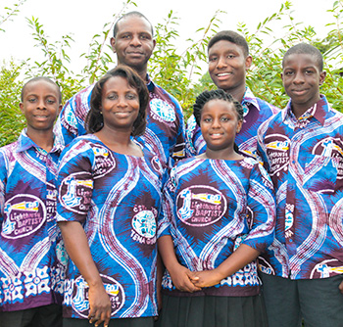

KEAST, WAYNE & TERRI
AFBM, Fayetteville, NC
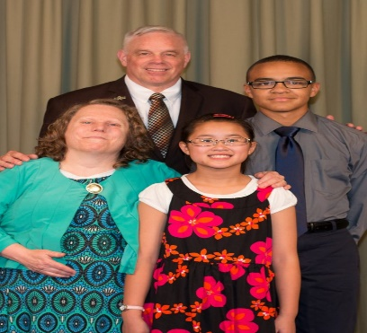

LAWSON, BRIAN & JESSICA
Brazil
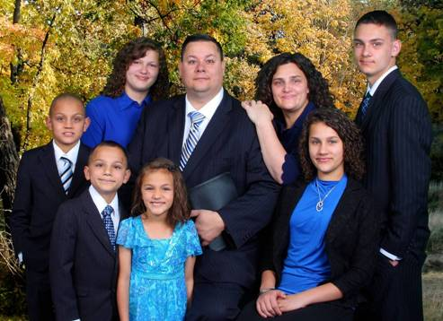

LIGHTHOUSE LEGAL MINISTRY, Robideau, Jim
Ohio
Christian Legal
Outreach Ministry
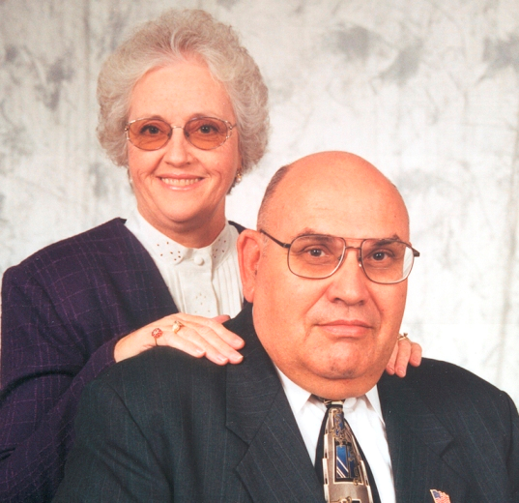Outreach Ministry
LONG, DAVID & TERRI
Couva, Trinidad, WI
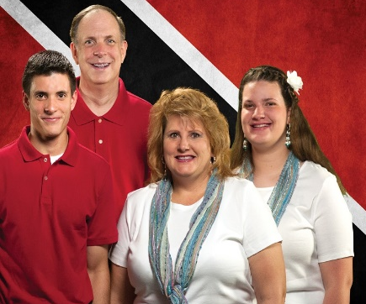

MCKEEVER, LINDA
Ministry of Ladies, USA
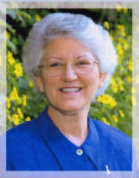

OTTOSEN, JASON & CHERITH
Gulf Province, Papua New Guinea
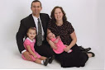

PAYNE, RICARDO & MARY
Washington, DC

PHELPS, CHUCK & SUE
Grain Valley, Missouri
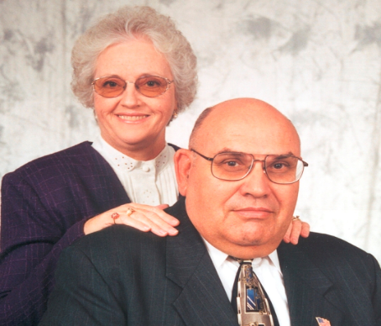
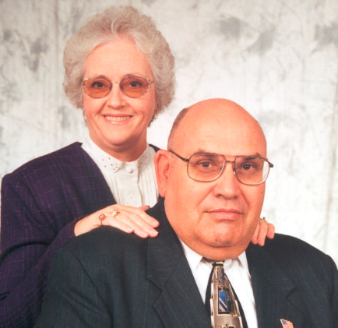
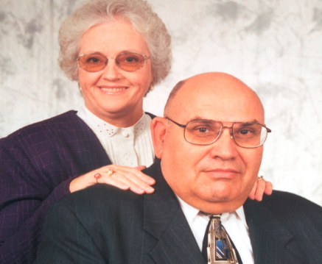

REYES, FERNANDO & AURA
Vietnam, Dominican Republic
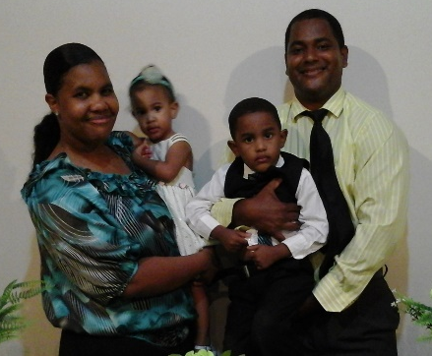

RITCHIE, JASON & MARY
Ulaanbaatar, Mongolia
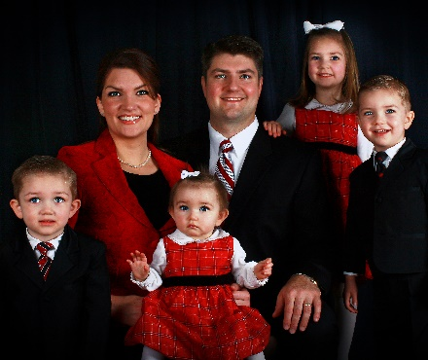

SIDLER, STEVE & NOHEMY
Dominican Republic
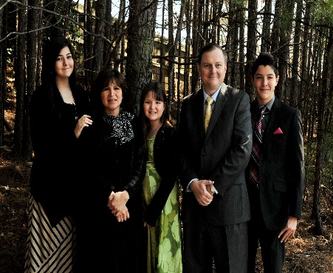

SMITH, ROBERT & CATHY
Sao Paulo Brazil
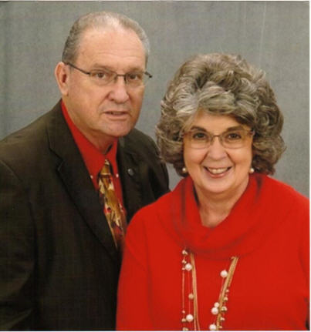

SMITH, SHELTON
SOL Publisher, Mission Outreach, USA

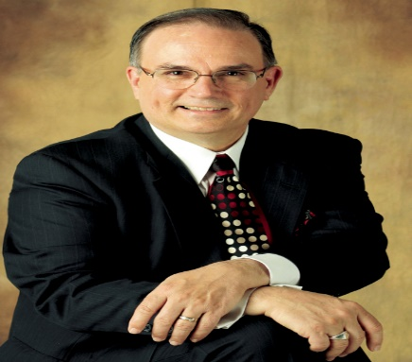

WAR, CHRIS & LOUANNE
U.S. Military, Aviano, Italy
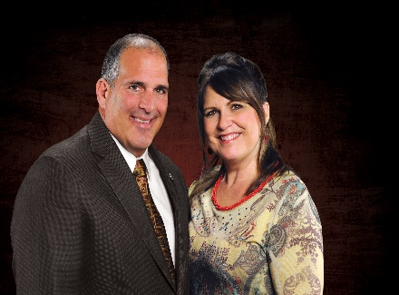

WARD, HENRY & CELESTE
Kobe, Hyogo Prefecture, Kita-ku, Japan
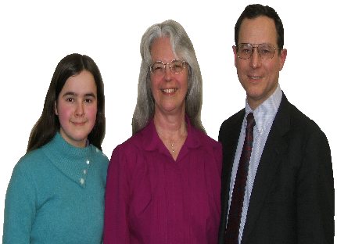

WILSON, ETHEL
Okosuka-Shi, Kanagawa-Ken, Japan
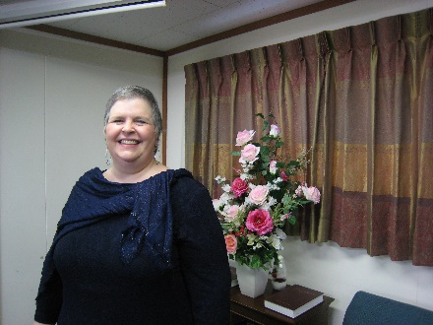

WYNN, JOHN & CHRISTI
Tacloban, Leyte, Philippines
